Calibration weights
# Source: AI Source: Provided by: [Data Path: Persons Table -> ID Column: 1, Name_En Column: Motasem Essam] -> From: [ChatGPT] on [7/17/2026]
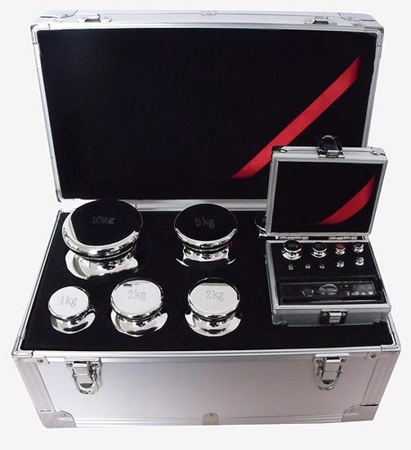
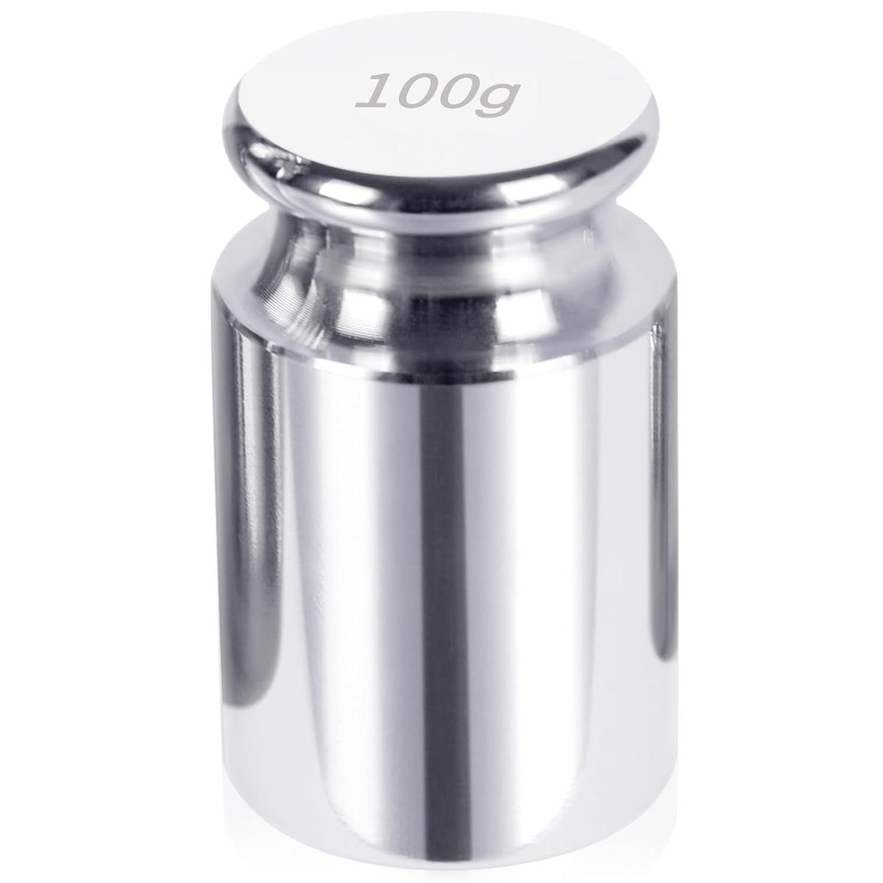
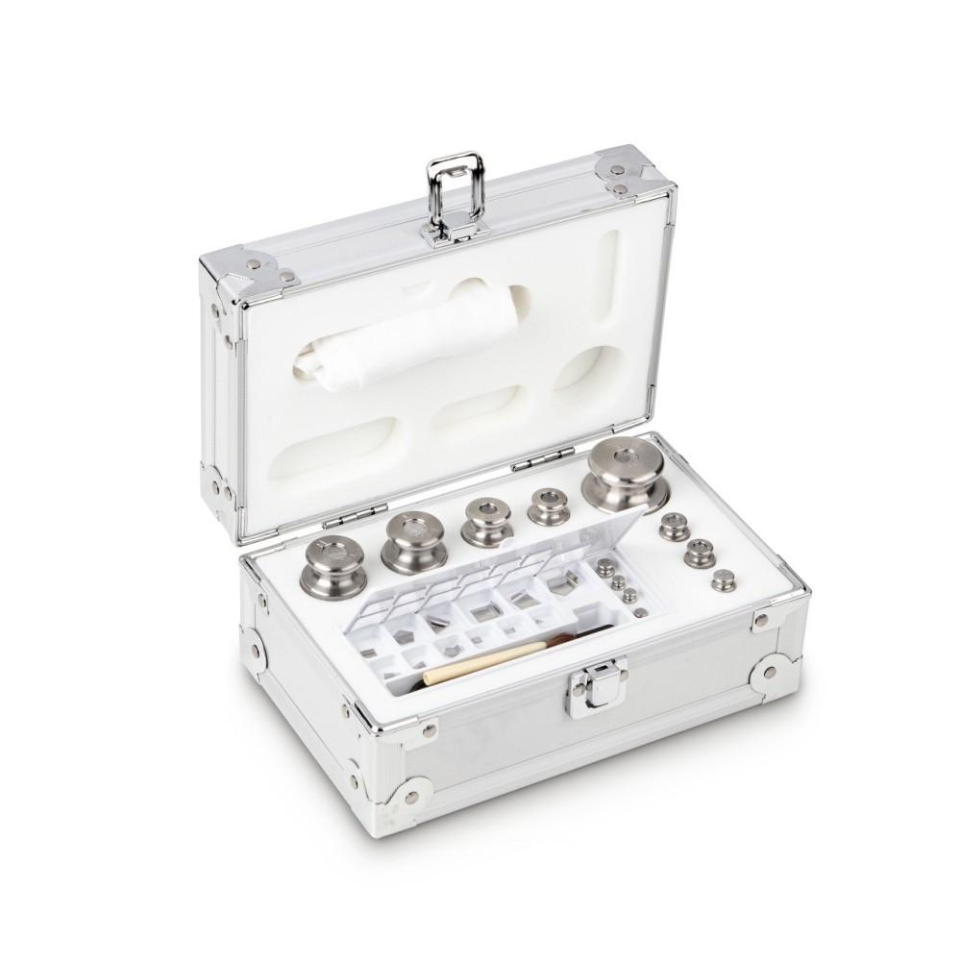
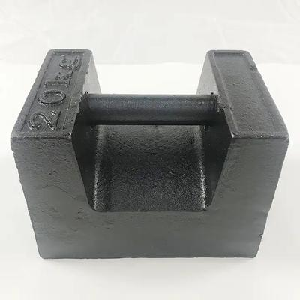
Calibration Weights (also called Standard Weights, Reference Weights, or Test Weights) are precision-manufactured masses used to calibrate, verify, adjust, and test balances and weighing scales. Their masses are certified and traceable to national or international measurement standards.
Calibration weights are essential in metrology, laboratories, manufacturing, pharmaceuticals, quality control, education, and industrial weighing.

Definition
# Source: AI Source: Provided by: [Data Path: Persons Table -> ID Column: 1, Name_En Column: Motasem Essam] -> From: [ChatGPT] on [7/17/2026]
Calibration Weights are precision reference masses with certified values used to verify, calibrate, and adjust weighing instruments.

Purpose
# Source: AI Source: Provided by: [Data Path: Persons Table -> ID Column: 1, Name_En Column: Motasem Essam] -> From: [ChatGPT] on [7/17/2026]
Calibration weights are used to:
- Calibrate balances.
- Verify weighing scales.
- Test measurement accuracy.
- Check repeatability.
- Adjust weighing instruments.
- Maintain measurement traceability.
- Meet quality standards.

Principle of Operation
# Source: AI Source: Provided by: [Data Path: Persons Table -> ID Column: 1, Name_En Column: Motasem Essam] -> From: [ChatGPT] on [7/17/2026]
A calibration weight has a known certified mass.
When placed on a balance or scale:
- The instrument measures the weight.
- The displayed value is compared with the certified value.
- Any difference indicates measurement error.
- The instrument may then be adjusted or recalibrated.

Main Characteristics
# Source: AI Source: Provided by: [Data Path: Persons Table -> ID Column: 1, Name_En Column: Motasem Essam] -> From: [ChatGPT] on [7/17/2026]
Calibration weights are manufactured to:
- Very tight mass tolerances.
- High dimensional stability.
- Corrosion resistance.
- Low magnetic susceptibility (high-quality models).
- Smooth polished surfaces for easy cleaning.

Main Components
# Source: AI Source: Provided by: [Data Path: Persons Table -> ID Column: 1, Name_En Column: Motasem Essam] -> From: [ChatGPT] on [7/17/2026]
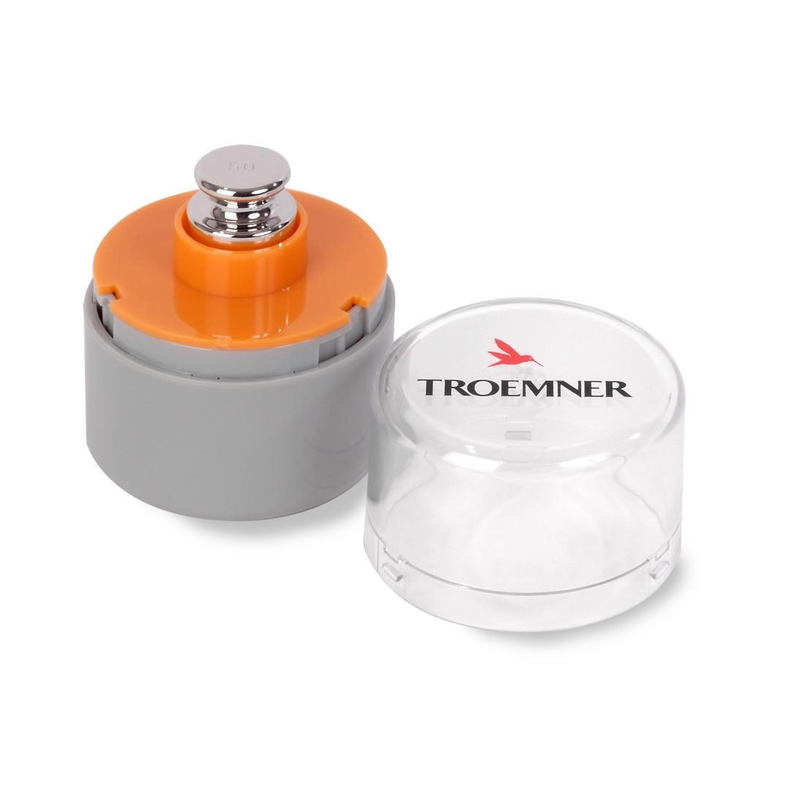
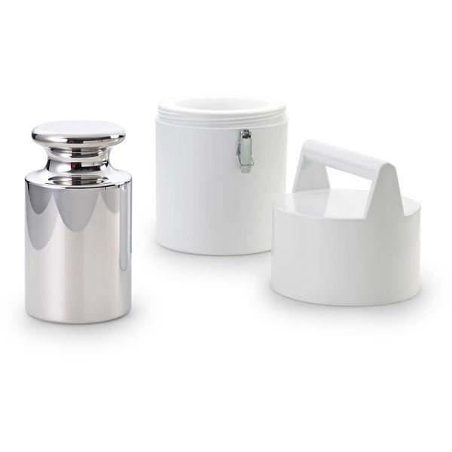
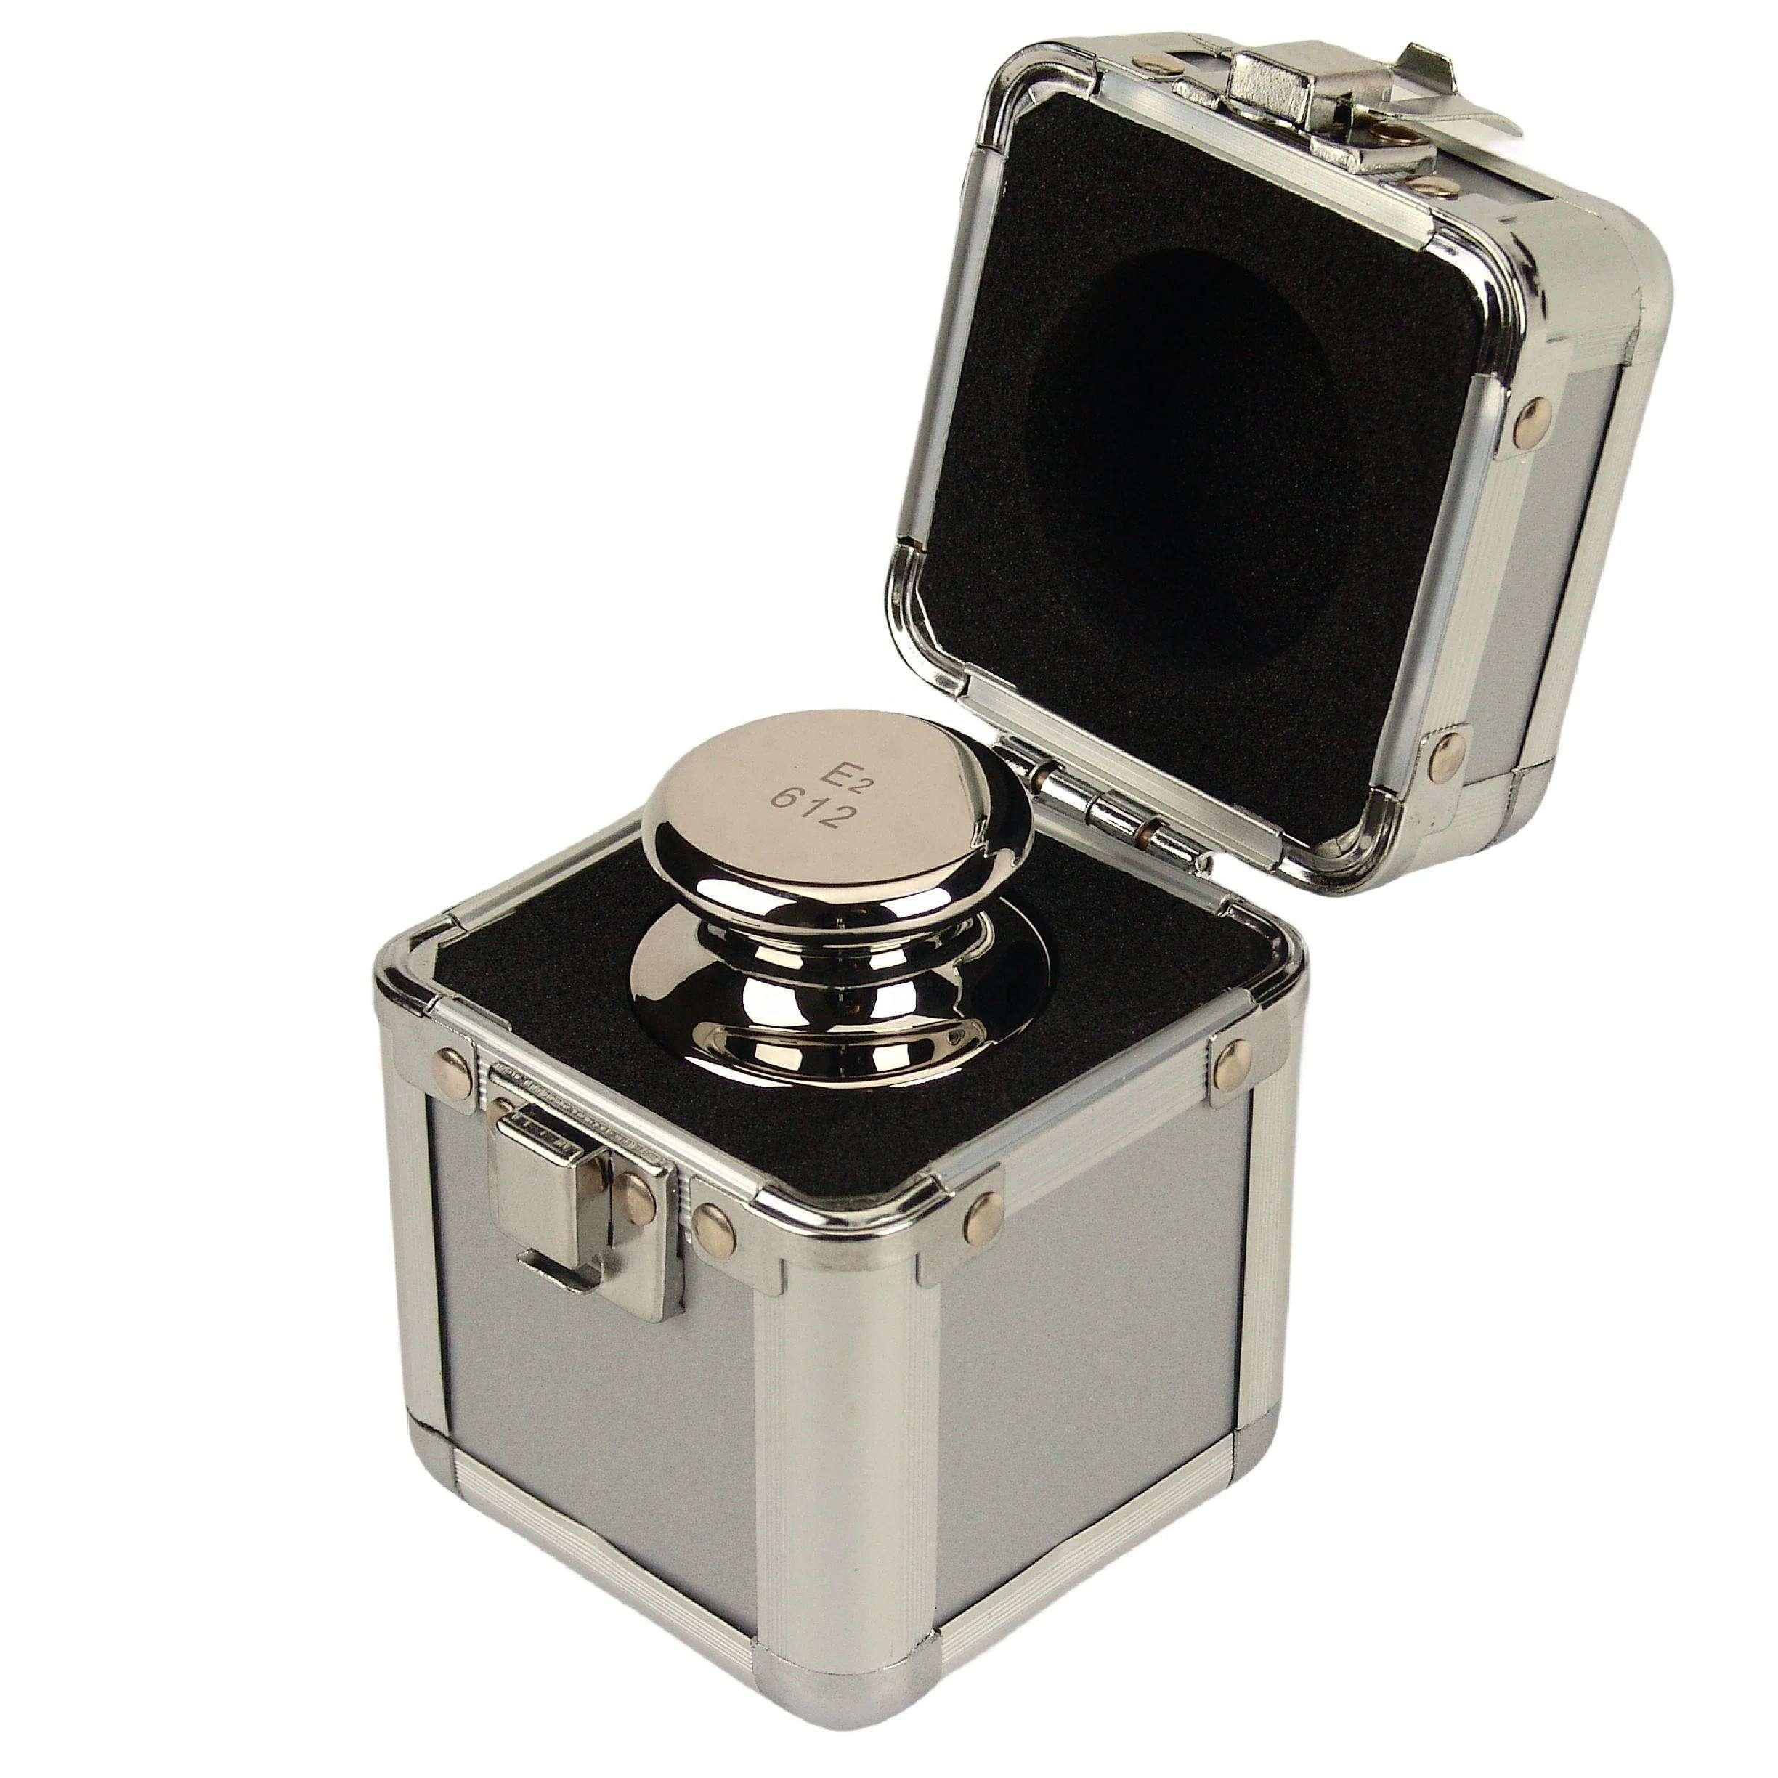
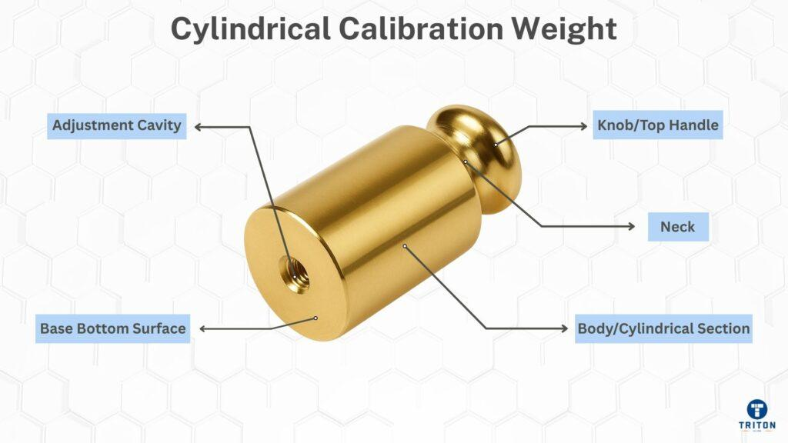
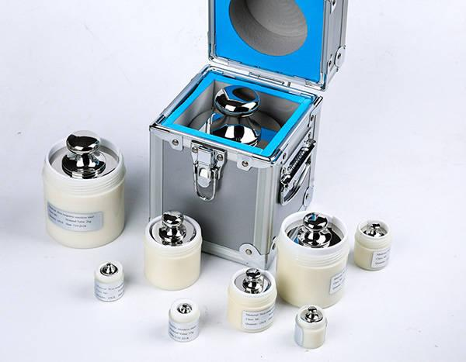
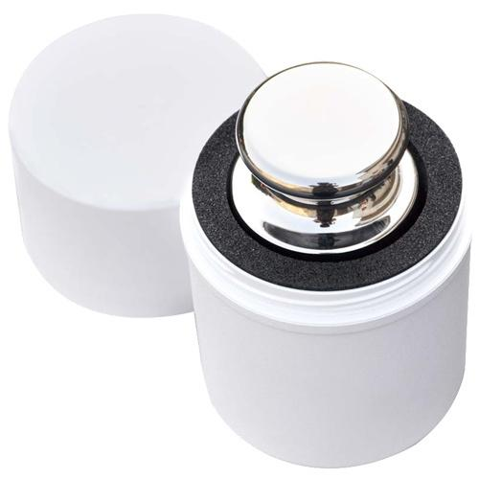
A calibration weight typically includes:
- Weight body
- Lifting knob (larger weights)
- Identification marking
- Protective storage case (weight sets)
- Calibration certificate (certified weights)

Types of Calibration Weights

1. Cylindrical Stainless Steel Weights
# Source: AI Source: Provided by: [Data Path: Persons Table -> ID Column: 1, Name_En Column: Motasem Essam] -> From: [ChatGPT] on [7/17/2026]
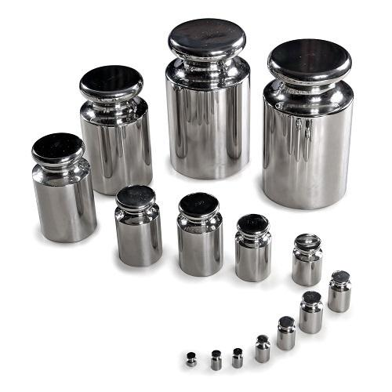
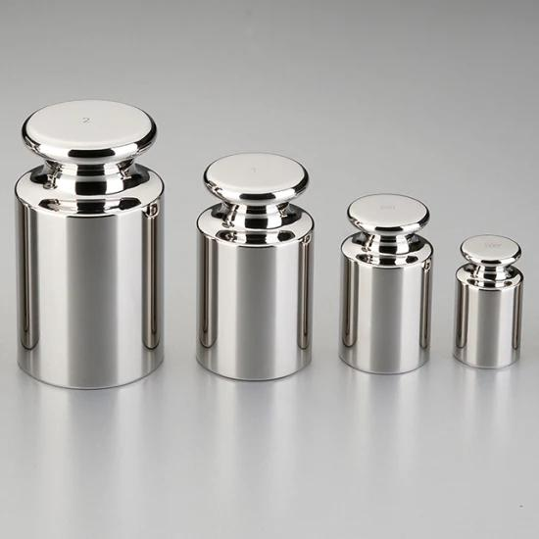
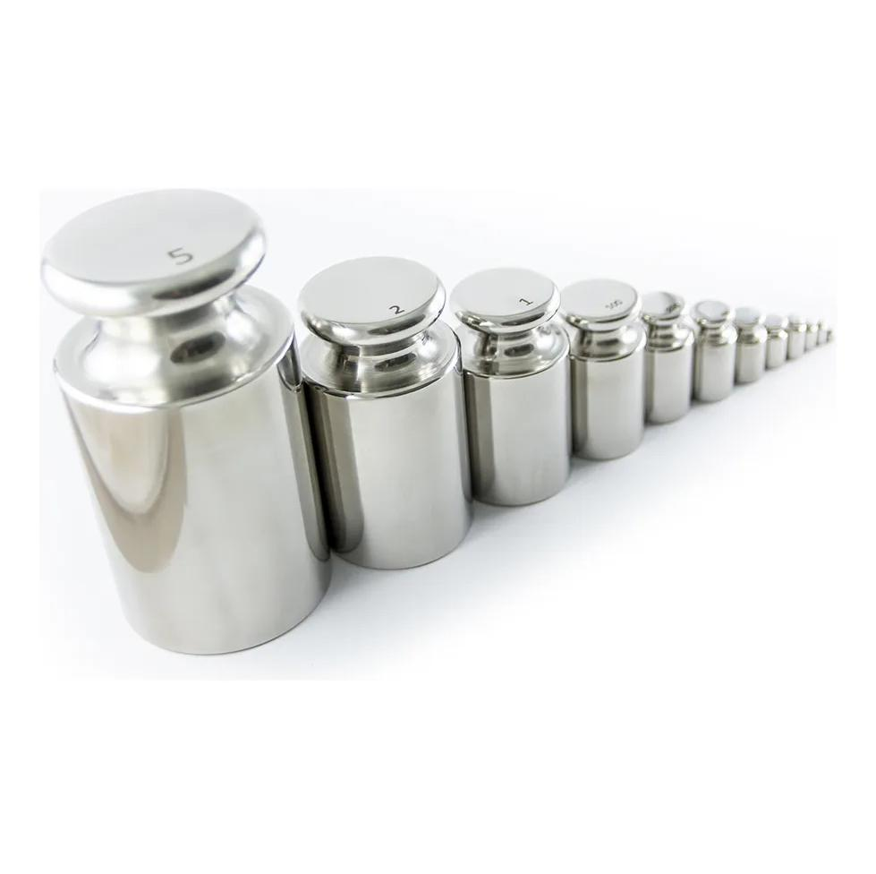
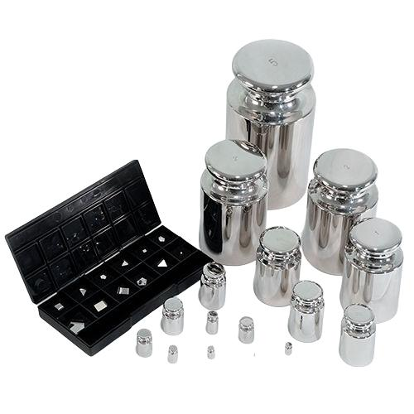
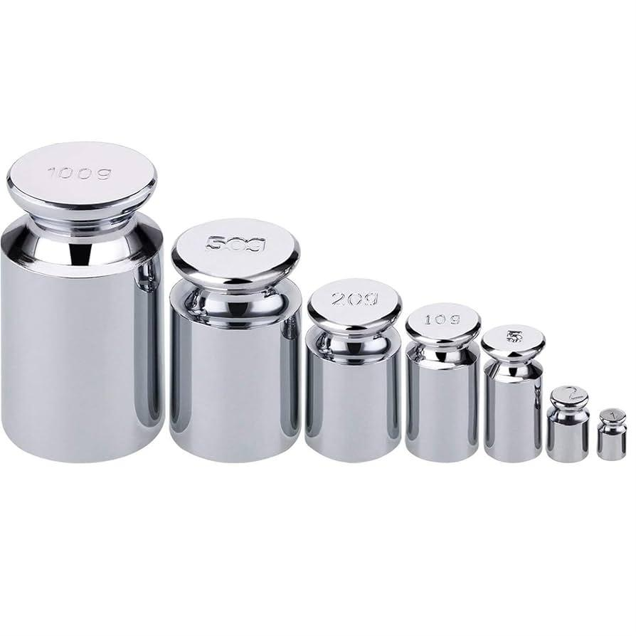
Description
The most common laboratory calibration weights.
Features
- High corrosion resistance
- Excellent stability
- Precision-machined
- Polished finish
Applications
- Analytical balances
- Precision balances
- Calibration laboratories

2. Slotted Weights
# Source: AI Source: Provided by: [Data Path: Persons Table -> ID Column: 1, Name_En Column: Motasem Essam] -> From: [ChatGPT] on [7/17/2026]
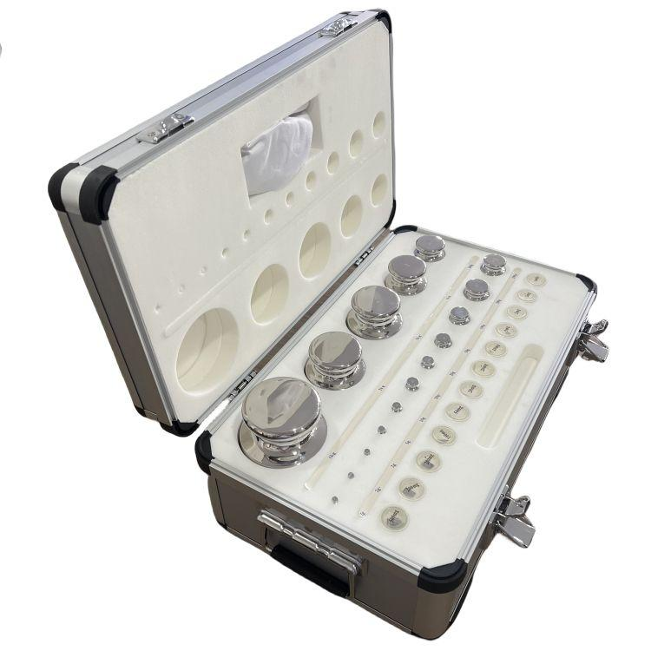
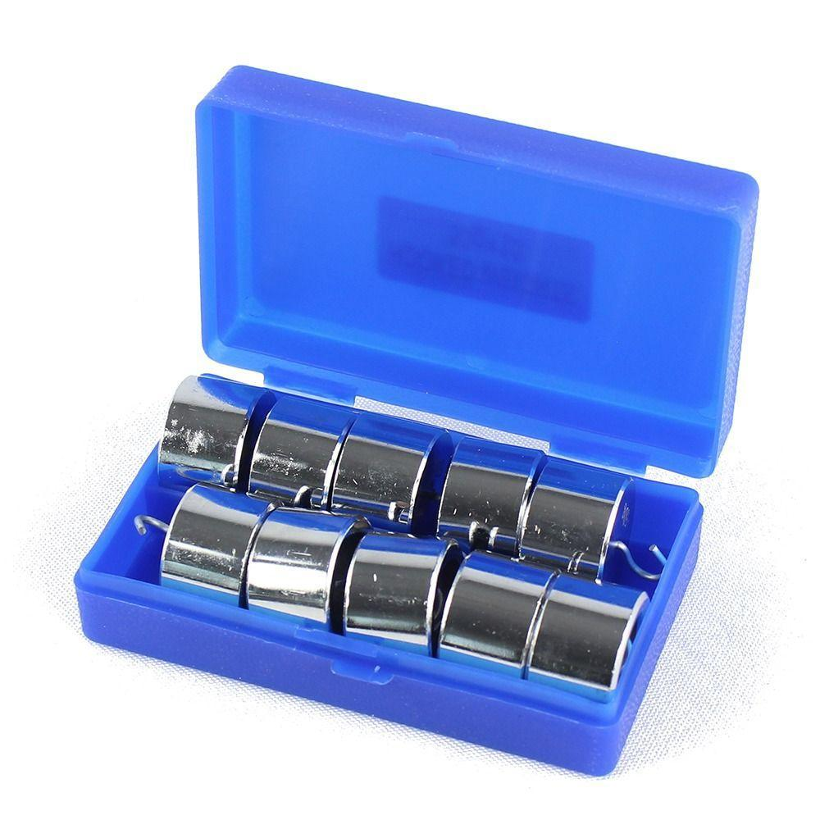
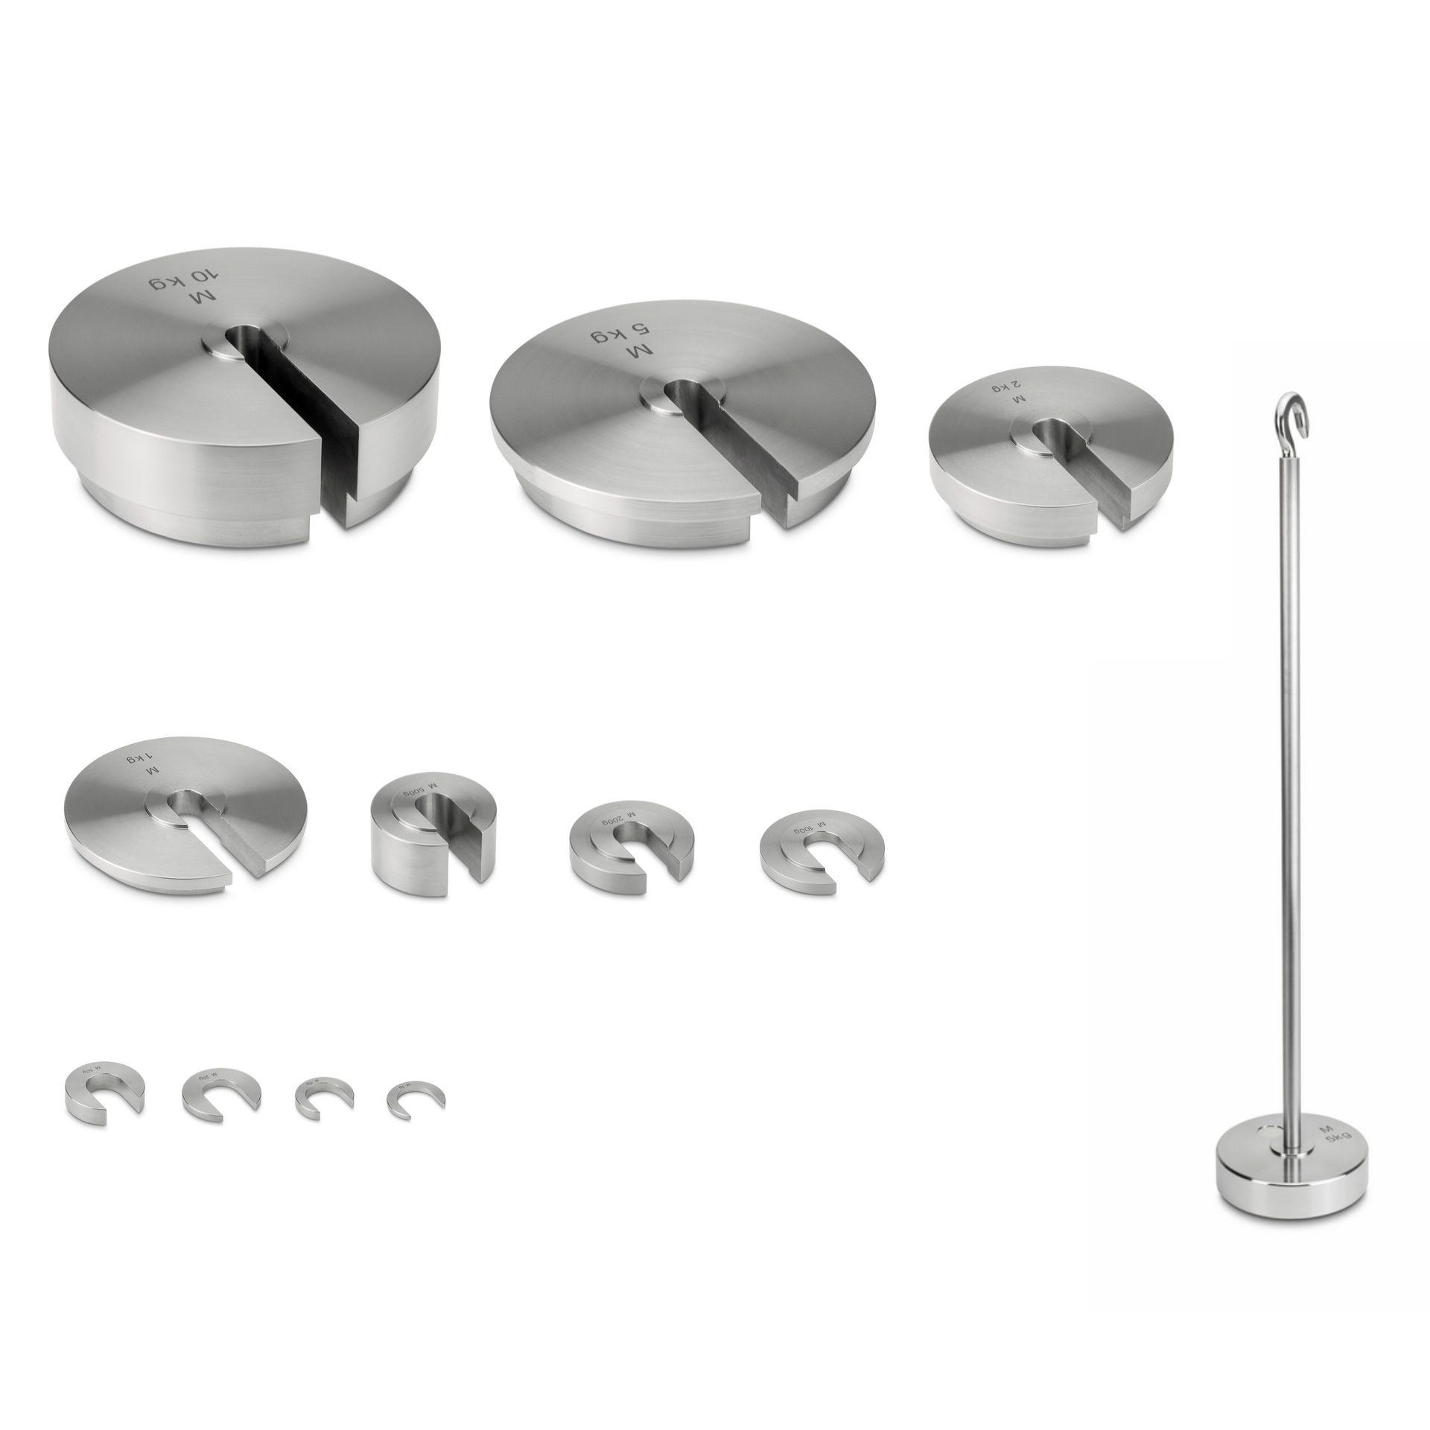
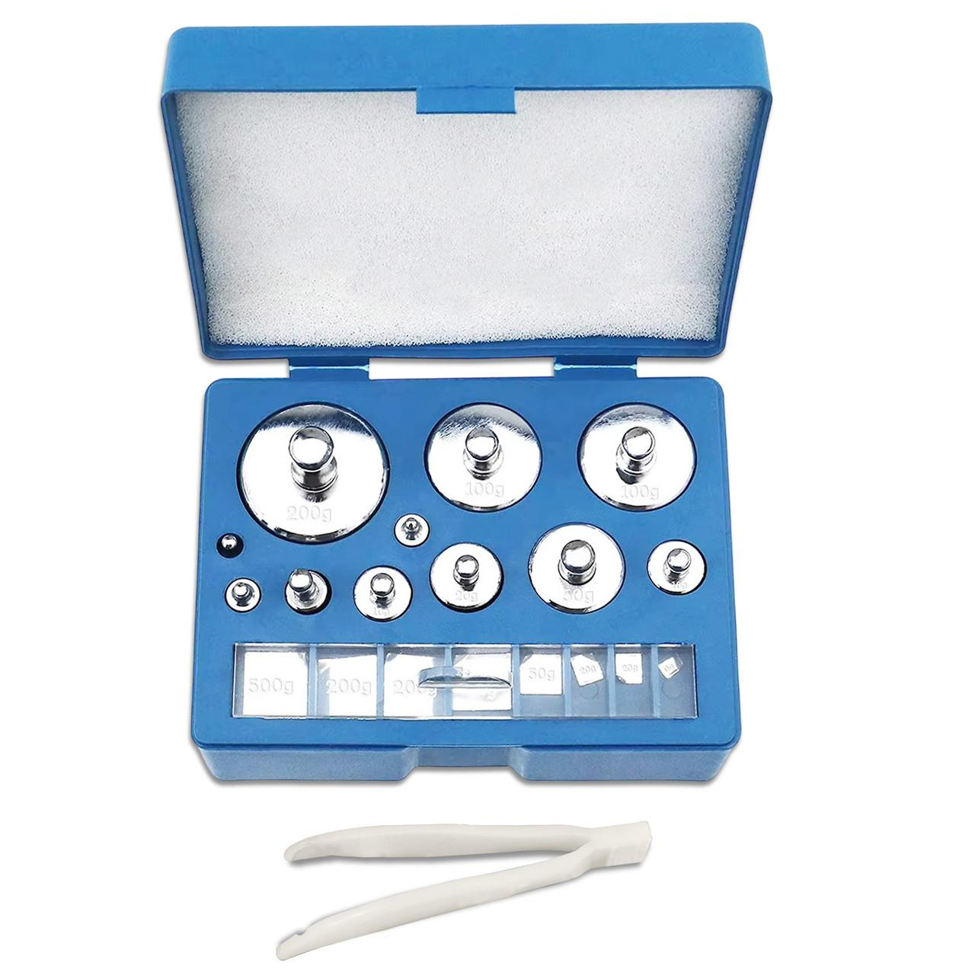
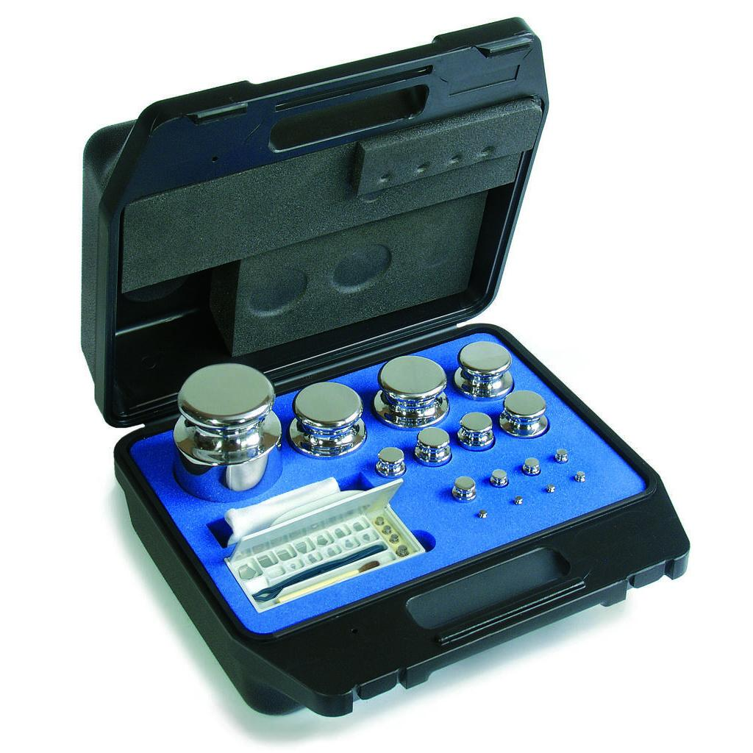
Description
Weights with a slot that fit over a support rod.
Applications
- Physics laboratories
- Force experiments
- Educational demonstrations

3. Cast Iron Calibration Weights
# Source: AI Source: Provided by: [Data Path: Persons Table -> ID Column: 1, Name_En Column: Motasem Essam] -> From: [ChatGPT] on [7/17/2026]
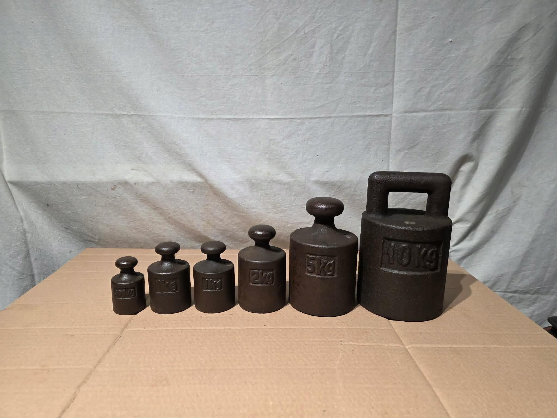
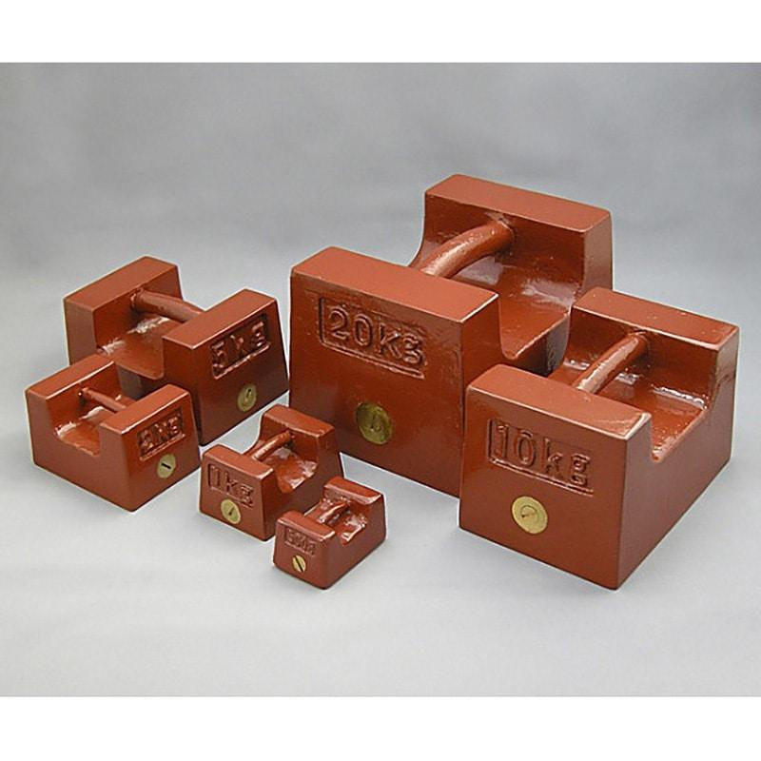
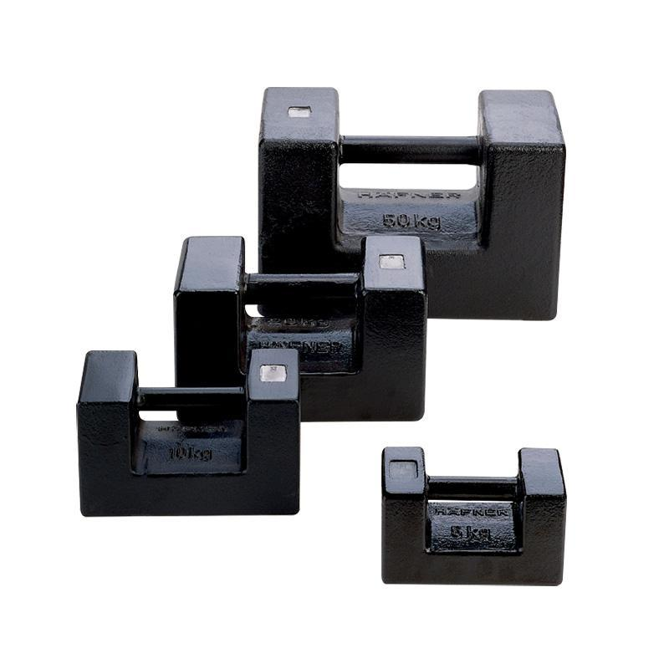
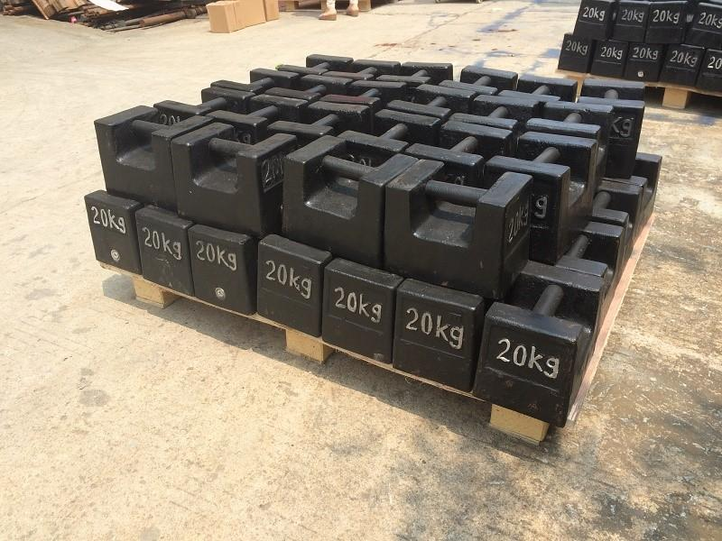
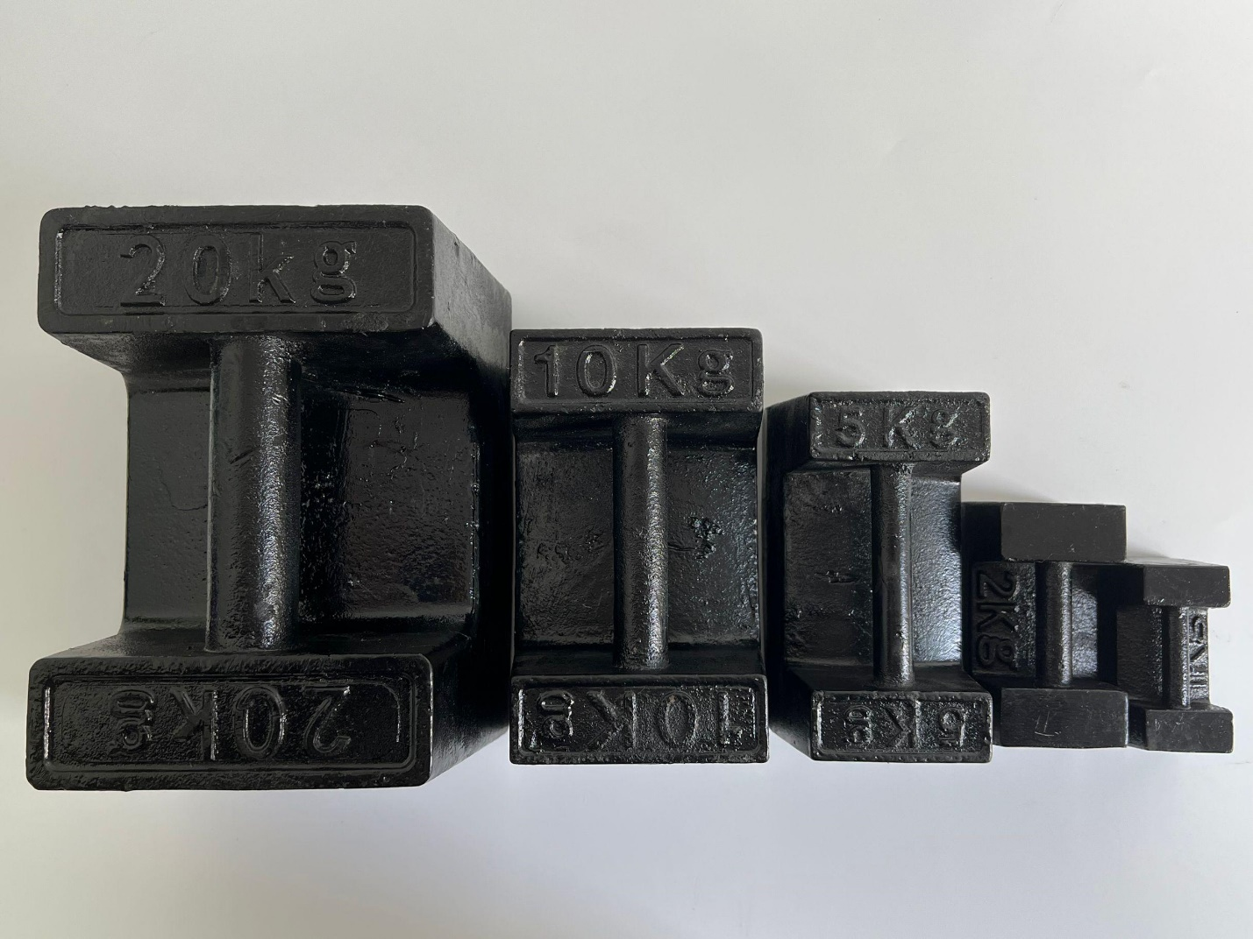
Description
Heavy-duty calibration weights used for industrial scales.
Features
- Large capacity
- Durable
- Suitable for field calibration
Applications
- Platform scales
- Truck scales
- Industrial weighing systems

4. Wire or Sheet Weights
# Source: AI Source: Provided by: [Data Path: Persons Table -> ID Column: 1, Name_En Column: Motasem Essam] -> From: [ChatGPT] on [7/17/2026]
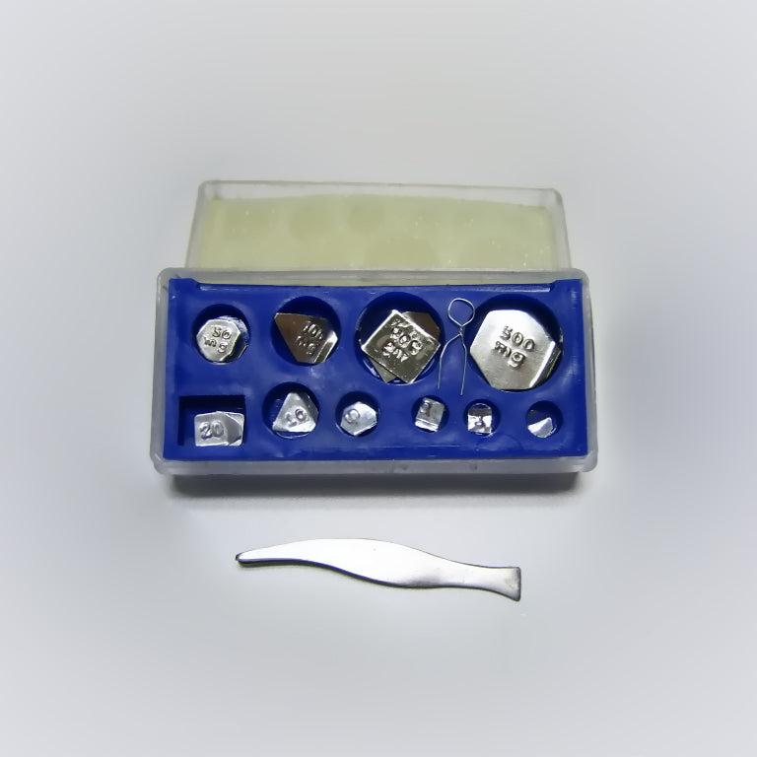
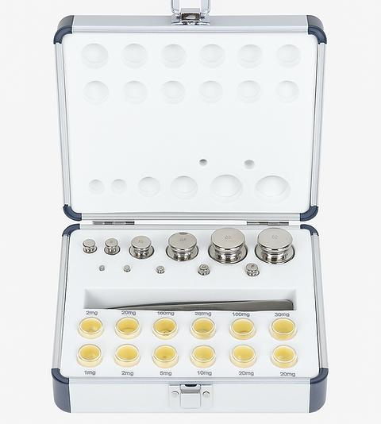
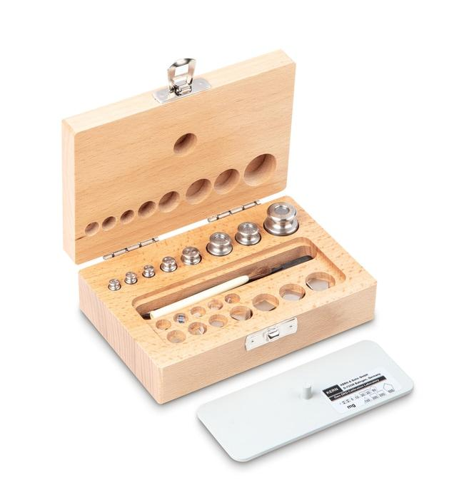
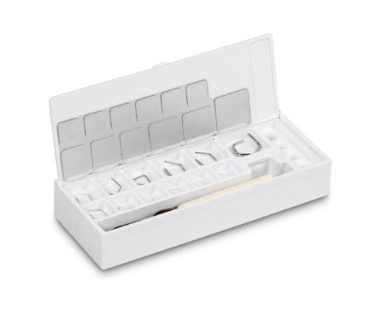
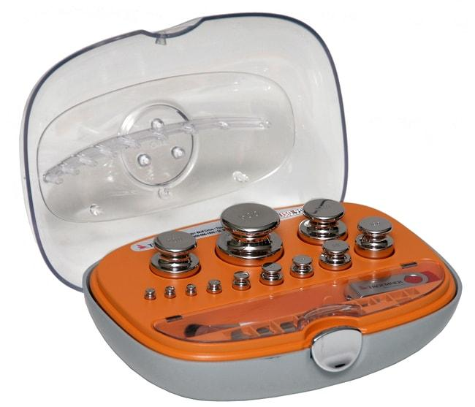
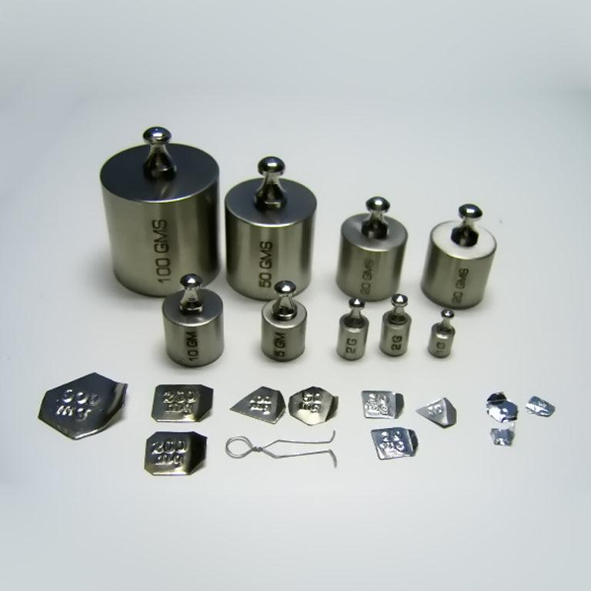
Description
Very small calibration weights used for analytical balances.
Measuring Range
Typically:
- 1 mg
- 2 mg
- 5 mg
- 10 mg
Applications
- Analytical chemistry
- Pharmaceutical laboratories
- Scientific research

OIML Accuracy Classes
# Source: AI Source: Provided by: [Data Path: Persons Table -> ID Column: 1, Name_En Column: Motasem Essam] -> From: [ChatGPT] on [7/17/2026]
Calibration weights are commonly classified according to the International Organization of Legal Metrology (OIML).
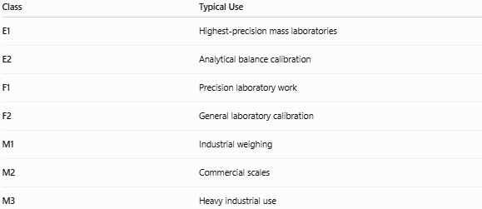
Class | Typical Use
E1 | Highest-precision mass laboratories
E2 | Analytical balance calibration
F1 | Precision laboratory work
F2 | General laboratory calibration
M1 | Industrial weighing
M2 | Commercial scales
M3 | Heavy industrial use

Common Mass Values
# Source: AI Source: Provided by: [Data Path: Persons Table -> ID Column: 1, Name_En Column: Motasem Essam] -> From: [ChatGPT] on [7/17/2026]
Calibration weights are available in many sizes, including:
- 1 mg
- 2 mg
- 5 mg
- 10 mg
- 20 mg
- 50 mg
- 100 mg
- 200 mg
- 500 mg
- 1 g
- 2 g
- 5 g
- 10 g
- 20 g
- 50 g
- 100 g
- 200 g
- 500 g
- 1 kg
- 2 kg
- 5 kg
- 10 kg
- 20 kg
- 50 kg

Materials Used
# Source: AI Source: Provided by: [Data Path: Persons Table -> ID Column: 1, Name_En Column: Motasem Essam] -> From: [ChatGPT] on [7/17/2026]
Common materials include:
- Stainless steel
- Brass
- Nickel-plated brass
- Cast iron
- Special non-magnetic alloys

How to Use Calibration Weights
# Source: AI Source: Provided by: [Data Path: Persons Table -> ID Column: 1, Name_En Column: Motasem Essam] -> From: [ChatGPT] on [7/17/2026]
- Clean the balance.
- Allow the balance to warm up (electronic models).
- Ensure the balance reads zero.
- Handle weights using tweezers or gloves (small weights).
- Place the calibration weight gently on the center of the weighing pan.
- Compare the displayed value with the certified value.
- Record the results or perform calibration if necessary.

Example
# Source: AI Source: Provided by: [Data Path: Persons Table -> ID Column: 1, Name_En Column: Motasem Essam] -> From: [ChatGPT] on [7/17/2026]
Certified weight:
100.0000 g
Balance reading:
99.9989 g
Error:
$$100.0000-99.9989=0.0011\text{ g}$$
The balance may require adjustment depending on the acceptable tolerance.

Accuracy
# Source: AI Source: Provided by: [Data Path: Persons Table -> ID Column: 1, Name_En Column: Motasem Essam] -> From: [ChatGPT] on [7/17/2026]
Calibration weights are manufactured with extremely small tolerances.
Higher OIML classes have tighter permissible errors.

Sources of Error
# Source: AI Source: Provided by: [Data Path: Persons Table -> ID Column: 1, Name_En Column: Motasem Essam] -> From: [ChatGPT] on [7/17/2026]
Instrument Errors
- Balance calibration drift
- Load cell problems
- Mechanical wear

Weight Errors
- Dirt
- Dust
- Fingerprints
- Corrosion
- Physical damage

Handling Errors
- Touching weights with bare hands
- Dropping weights
- Incorrect storage

Environmental Errors
- Temperature changes
- Air currents
- Humidity
- Static electricity

Applications
# Source: AI Source: Provided by: [Data Path: Persons Table -> ID Column: 1, Name_En Column: Motasem Essam] -> From: [ChatGPT] on [7/17/2026]
Calibration weights are used in:
- Metrology laboratories
- Pharmaceutical laboratories
- Chemistry laboratories
- Manufacturing
- Food industry
- Quality control
- Scientific research
- Universities
- Industrial weighing
- Government calibration centers

Advantages
# Source: AI Source: Provided by: [Data Path: Persons Table -> ID Column: 1, Name_En Column: Motasem Essam] -> From: [ChatGPT] on [7/17/2026]
Calibration weights:
- Provide traceable reference masses.
- Improve weighing accuracy.
- Support quality assurance.
- Meet international standards.
- Can be used repeatedly for many years with proper care.

Limitations
# Source: AI Source: Provided by: [Data Path: Persons Table -> ID Column: 1, Name_En Column: Motasem Essam] -> From: [ChatGPT] on [7/17/2026]
Calibration weights:
- Require careful handling.
- Can be expensive (high-accuracy classes).
- Must be recalibrated periodically.
- Can become contaminated if improperly stored.

Comparison with Other Mass Standards
# Source: AI Source: Provided by: [Data Path: Persons Table -> ID Column: 1, Name_En Column: Motasem Essam] -> From: [ChatGPT] on [7/17/2026]
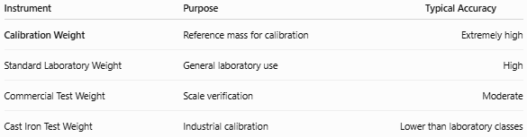
Instrument | Purpose | Typical Accuracy
Calibration Weight | Reference mass for calibration | Extremely high
Standard Laboratory Weight | General laboratory use | High
Commercial Test Weight | Scale verification | Moderate
Cast Iron Test Weight | Industrial calibration | Lower than laboratory classes

Care and Maintenance
# Source: AI Source: Provided by: [Data Path: Persons Table -> ID Column: 1, Name_En Column: Motasem Essam] -> From: [ChatGPT] on [7/17/2026]
To preserve accuracy:
- Handle with gloves or forceps.
- Never touch polished weights with bare hands.
- Store in the protective case.
- Keep clean and dry.
- Avoid scratches and impacts.
- Recalibrate according to the recommended schedule.

Common Mistakes
# Source: AI Source: Provided by: [Data Path: Persons Table -> ID Column: 1, Name_En Column: Motasem Essam] -> From: [ChatGPT] on [7/17/2026]
- Touching weights directly.
- Mixing different OIML classes.
- Using damaged weights.
- Storing weights outside their protective case.
- Ignoring calibration certificates.

Key Points
# Source: AI Source: Provided by: [Data Path: Persons Table -> ID Column: 1, Name_En Column: Motasem Essam] -> From: [ChatGPT] on [7/17/2026]
- Calibration Weights are precision reference masses.
- They are used to:
  - Calibrate balances
  - Verify scales
  - Check weighing accuracy
- Common types:
  - Stainless Steel Cylindrical Weights
  - Slotted Weights
  - Cast Iron Weights
  - Wire (Milligram) Weights
- Classified by OIML into classes such as E1, E2, F1, F2, M1, M2, and M3.
- Essential in metrology, laboratories, manufacturing, pharmaceuticals, and quality control.

Conclusion
# Source: AI Source: Provided by: [Data Path: Persons Table -> ID Column: 1, Name_En Column: Motasem Essam] -> From: [ChatGPT] on [7/17/2026]
Calibration Weights are the foundation of accurate mass measurement. By providing certified reference masses that are traceable to recognized standards, they allow balances and weighing scales to be calibrated, verified, and adjusted with confidence. Their precision, stability, and standardized accuracy classes make them indispensable tools in scientific research, industrial production, healthcare, pharmaceuticals, and quality assurance, ensuring reliable and consistent weighing results across a wide range of applications.

